Team Members:

Daksha Singhal_PES1201700847

Aishwarya Pramod_PES1201700770

Adithya Vardhan_PES1201700788

Rahul Pandia_PES1201700260

Assignment 6

ARIMA

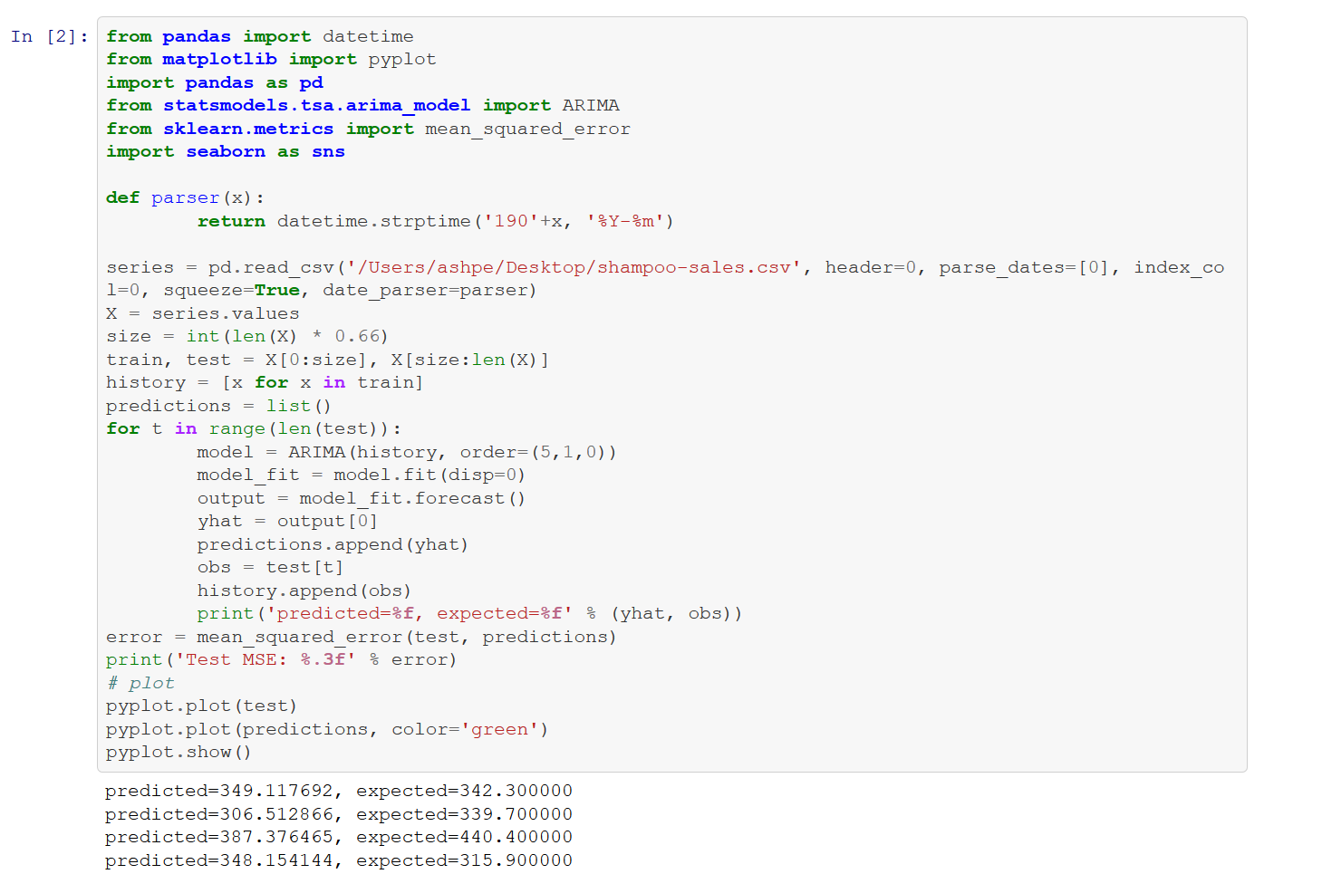

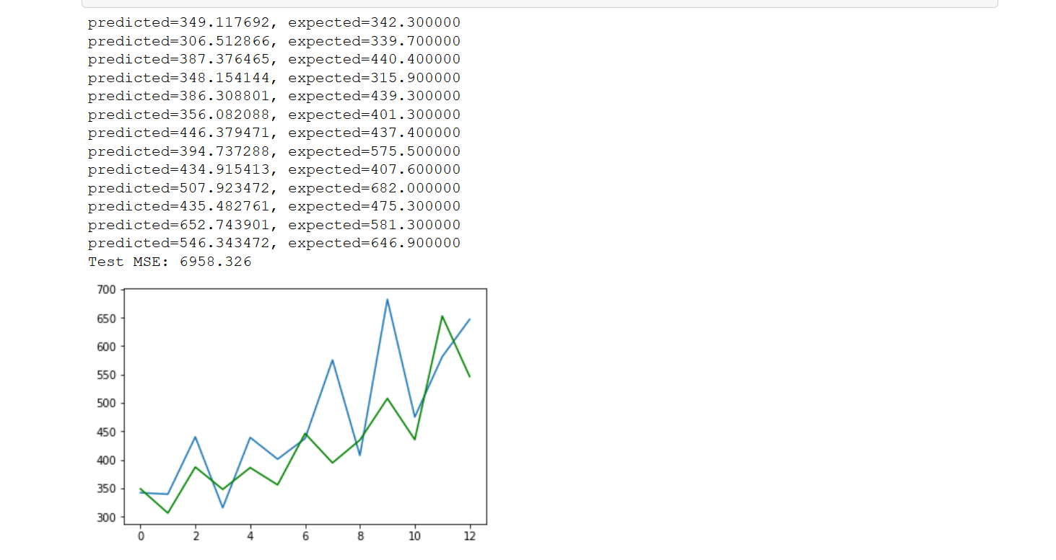

ARMA

